**Question (20 marks)**

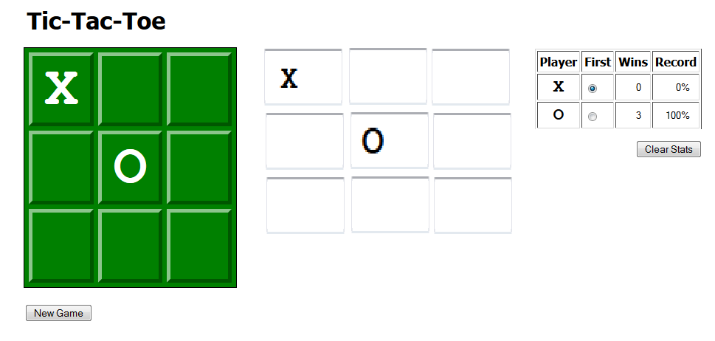

Part 1 (5 marks)

Design xhtml/CSS layout based on the above design.

Hint: You will need to create 3 divs.

1. First Div Will have the image based display of the current game. For the images assume “cross.png” for X and “zero.png” and “empty.png” for empty position. This div will also have a button to clear the images back to empty.
2. Next div will have 9 text boxes placed in form of a 3*3 picture as shown in the image above.
3. Last will have a Table as shown in the image above and image that reset the scores.

Part 2 (5 marks)

1. Apply javascript validation for the text boxes shown in div 2.
2. Following validation rules are to be applied.
   1. User can only enter X or O in the text boxes.
   2. Check if player 1 has entered an invalid entry for example the above image player 1 has selected X as symbol. So player 1 cannot enter O as symbol.
   3. Player 1 is not allowed to change symbol during game play.
3. Once user enters the correct symbol your program will than display the correct image at corresponding location in Div 1.

Part 3 (10 marks)

Once user enters the correct symbol and after updating the image in Div1 your program should than collect values of each text box in a javascript Array or Object reference types and pass to function named “checkGame” which will check for winner or tie.

checkGame: function will return 1 if player 1 is winner, 2 if player 2 is winner and 0 if it’s a tie.

Note: you are required to declare the java script function that takes an array or object as parameter for the text box values. You are not required to write Tic-Tac-Toe logic.

Once a winner is found your program update the scores and display a popup box displaying which player has won the game. Your program will also reset the textbox and images.